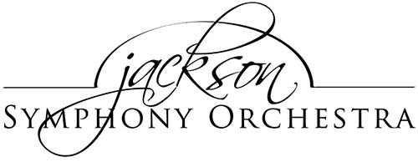

2018-19 Principal Keyboard Audition

The Jackson Symphony Orchestra announces PRINCIPAL KEYBOARD auditions for the 2019-20 season. The winning candidate will be offered a contract effective immediately. Based on these auditions, we may also add musicians to our supplemental musician list.

Date and time
Saturday, September 7, 2019. Auditions will begin at noon (12p).

Location
Jackson Symphony Orchestra Hall
215 W. Michigan Ave
Jackson MI 49201
Unlimited free street parking is available in front of our building

Repertoire
The audition repertoire has been attached. The candidate is responsible for providing their own music. The first round of this audition will be screened; subsequent rounds may or may not be screened.

Please mail a cover letter, one-page resume, and $25 deposit to the address above by August 26, 2019. Be sure to indicate “℅ David Lamse, JSO Personnel Manager” on any correspondence. Your deposit will be returned to you at audition check-in. No electronic submissions will be accepted. Personal checks should be made out to “Jackson Symphony Orchestra.” Please direct any questions to the Personnel Manager at jacksonsymphonypm@gmail.com.

2019-20 JSO principal pay-scale is $90/service with $25/travel allowance per round trip from E. Lansing and Ann Arbor. A typical JSO season includes 5 mainstage programs, one educational concert, several pops concerts, and many additional opportunities for outside performance and outreach. Not all concerts may require this position.

The audition committee of the Jackson Symphony Orchestra reserves the right to immediately dismiss any candidate that does not meet the highest professional standards at these auditions.

